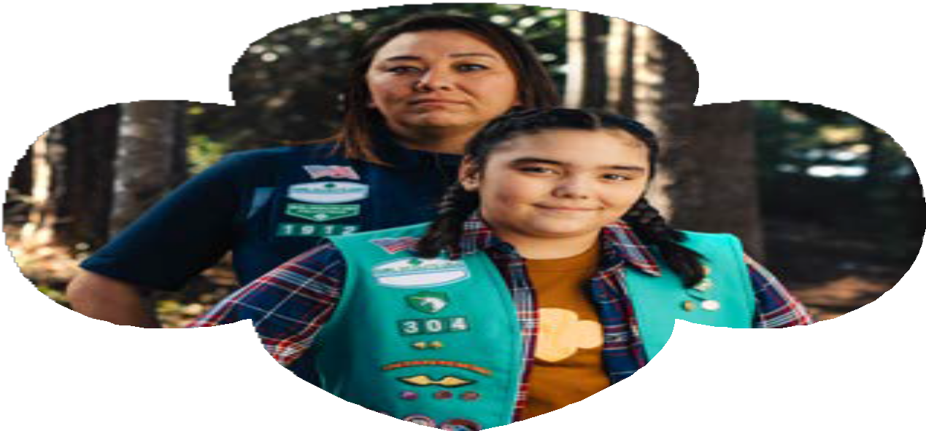You can make a difference.
Volunteer
with Girl Scouts.
We’re ready for you.

Help girls make friends, plan new adventures, and build a better world. There are opportunities for everyone.

Join us today at girlscoutshh.org/join

1-855-232-GSHH (4744)
customercare@girlscoutshh.org

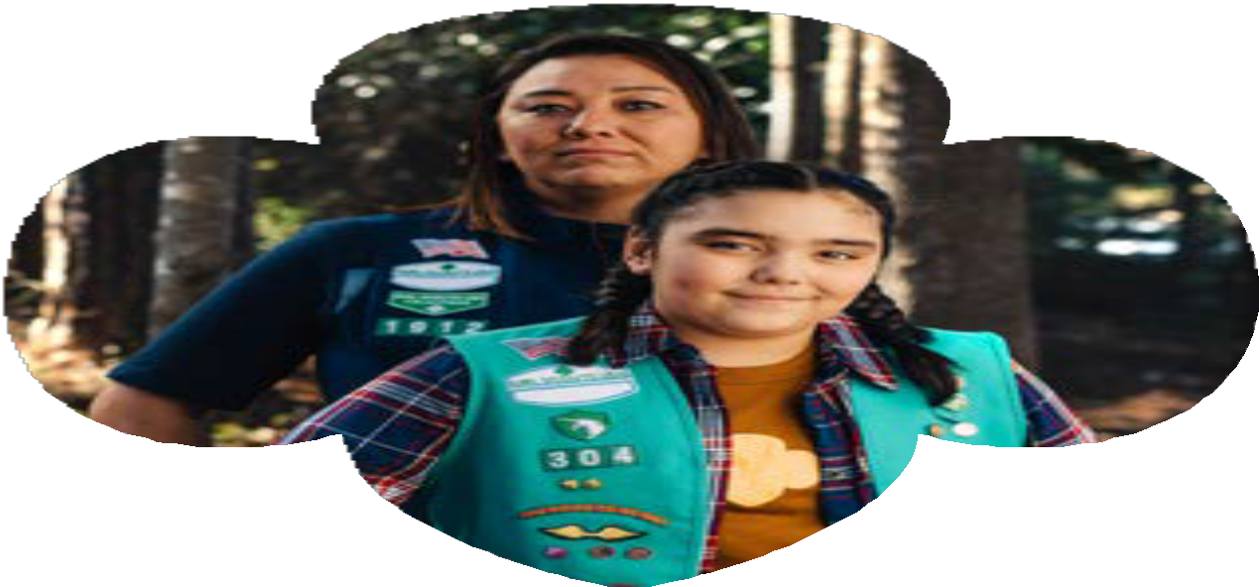

You can make a difference.
Volunteer
with Girl Scouts.
We’re ready for you.

Help girls make friends, plan new adventures, and build a better world. There are opportunities for everyone.

Join us today at girlscoutshh.org/join

1-855-232-GSHH (4744)
customercare@girlscoutshh.org

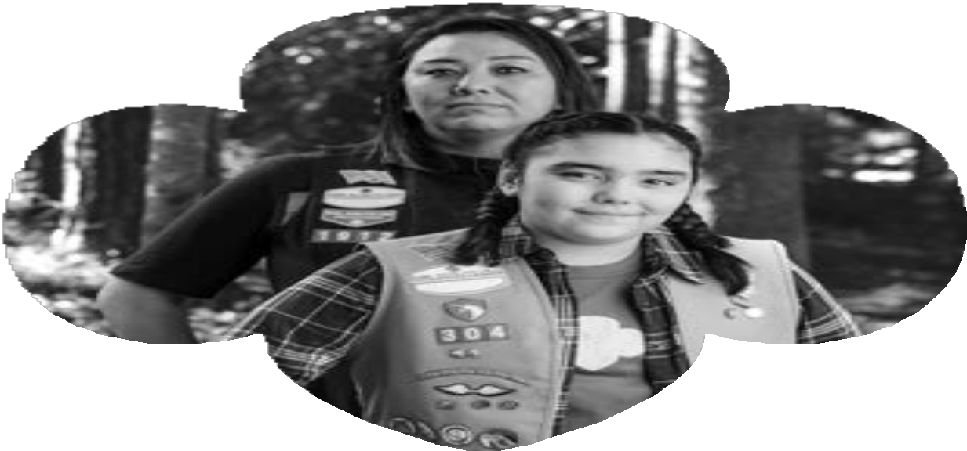You can make a difference.
Volunteer
with Girl Scouts.
We’re ready for you.

Help girls make friends, plan new adventures, and build a better world. There are opportunities for everyone.
Join us today at girlscoutshh.org/join

1-855-232-GSHH (4744)
customercare@girlscoutshh.org

You can make a difference.
Volunteer
with Girl Scouts.
We’re ready for you.

Help girls make friends, plan new adventures, and build a better world. There are opportunities for everyone.

Join us today at girlscoutshh.org/join

1-855-232-GSHH (4744)
customercare@girlscoutshh.org

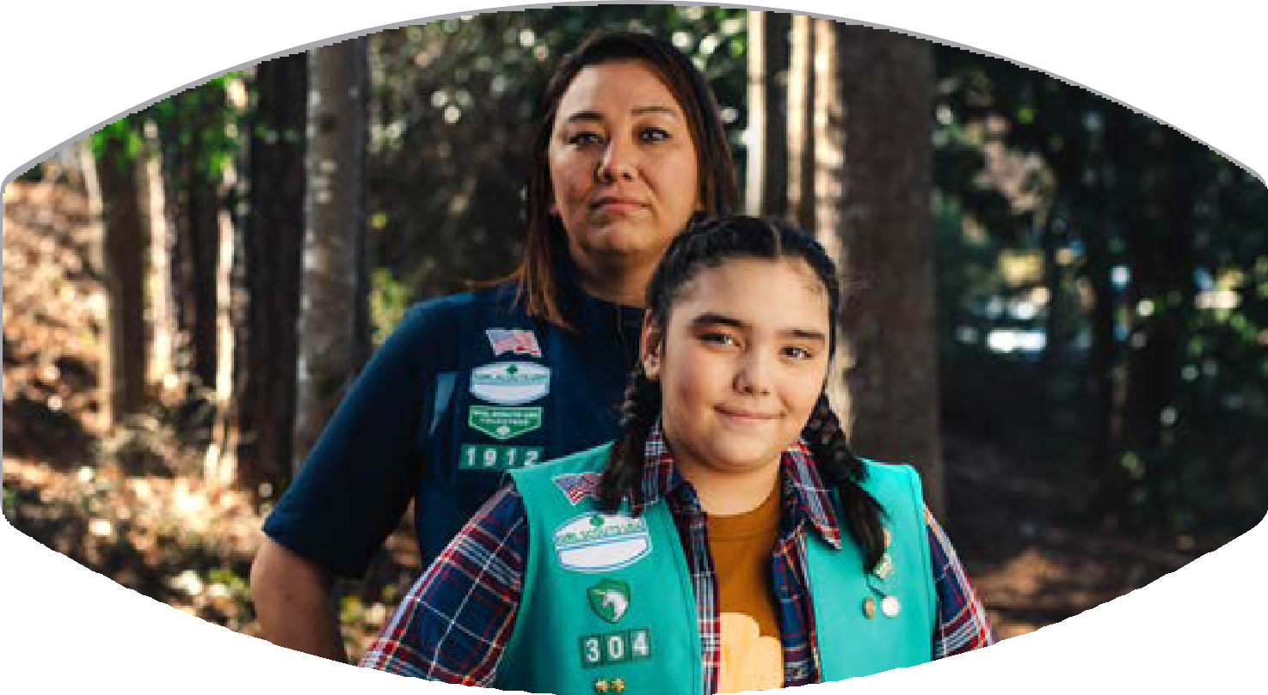

You can make a difference.

Volunteer with Girl Scouts. We’re ready for you.

Help girls make friends, plan new adventures, and build a better world. There are opportunities for everyone.

Join us today at girlscoutshh.org/join

1-855-232-GSHH (4744)
customercare@girlscoutshh.org

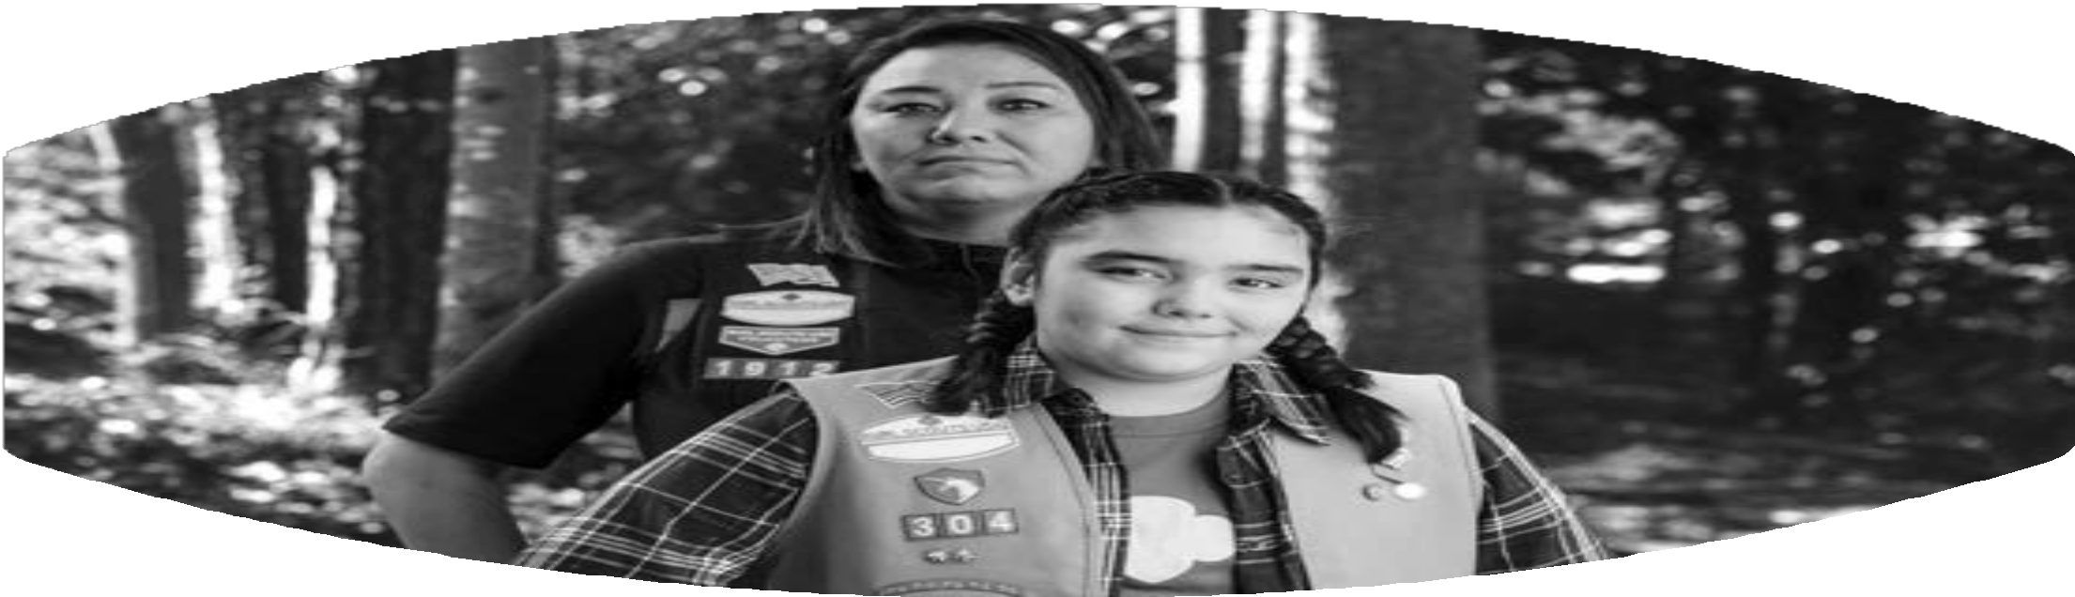

You can make a difference.
Volunteer with Girl Scouts. We’re ready for you.
Help girls make friends, plan new adventures, and build a better world. There are opportunities for everyone.

Join us today at girlscoutshh.org/join

1-855-232-GSHH (4744)
customercare@girlscoutshh.org

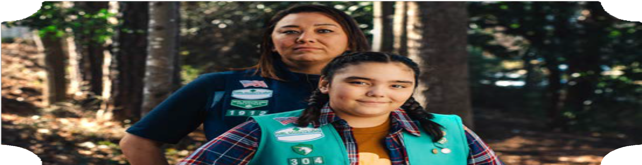You can make a difference.

Volunteer with Girl Scouts. We’re ready for you.

Help girls make friends, plan new adventures, and build a better world. There are opportunities for everyone.

Join us today at [custom council url]

Area for Customized Council Copy

You can make a difference.
Volunteer with Girl Scouts. We’re ready for you.
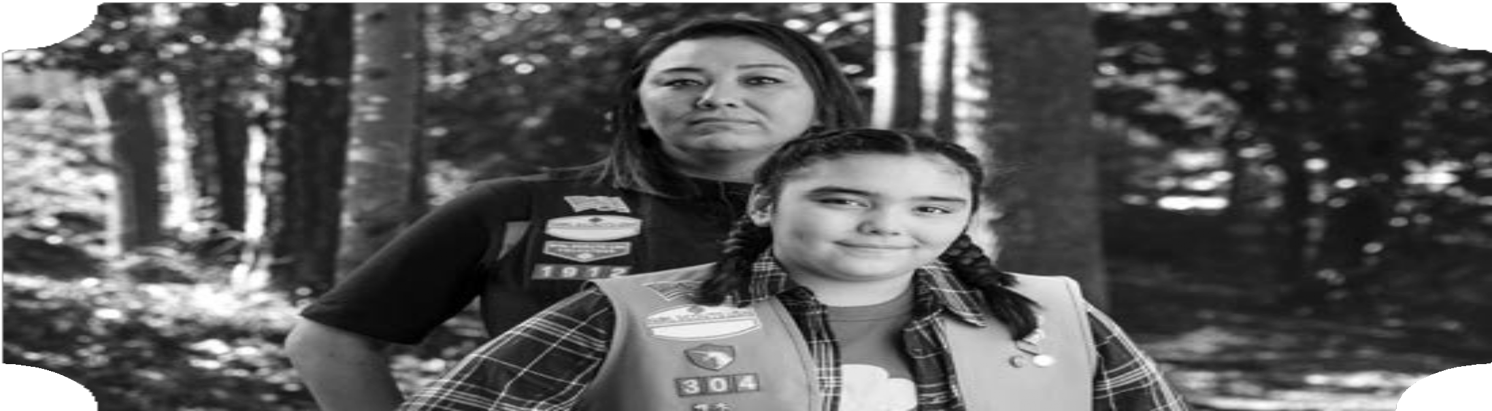
Help girls make friends, plan new adventures, and build a better world. There are opportunities for everyone.

Join us today at [custom council url]

Area for Customized Council Copy

