You’re invited!

Animal

Dance Party

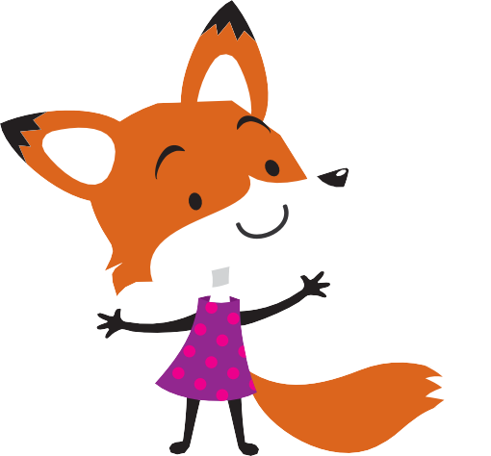
FREE Animal
Dance Party
[DATE AND TIME CUSTOMIZABLE]
At [LOCATION CUSTOMIZABLE]
ADMITS YOU + A FRIEND!
TICKET!
TICKET!

Bring a friend, make new ones, and get WILD on the dance floor with GIRL SCOUTS—it’s all FREE!
[Date Customizable] [XX–XXpm]
[Location Customizable] [Address, City, State Customizable]
Parents & Caregivers, you’re invited too! Get more information and RSVP at girlscoutshh.org or contact Customer Care
at customercare@girlscoutshh.org

