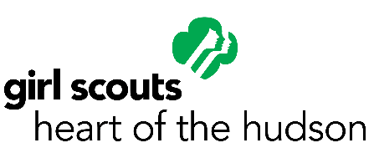

Girls Scouts Heart of the Hudson (GSHH)
Position Description

Position Title: Program/Field Aide

Reports To: Senior Program Manager

POSITION SUMMARY

The Program/Field Aide provides direct services to girls within a troop/group setting for Girl Scouts Heart of the Hudson, Inc. (GSHH). S/he is responsible for the introduction and coordination of Girl Scout program delivery and overall communication between GSHH and community partners. The Program/Field Aide works directly with GSHH Membership and Program staff to ensure that innovative programs are developed, implemented and evaluated which meets the needs of girls ages 5 to 17.

ESSENTIAL FUNCTIONS AND TYPICAL ACCOUNTABILITIES

Collaborate with designated GSHH staff to develop a plan of work, determine locations and times for Girl Scout program activities, and assist with planning and implementing recruitment opportunities for specific program activities and for community partners.

Receive training to ensure understanding of the Girl Scout program delivery.

Plan and implement program activities; ensure paperwork is completed for all girl members, maintain attendance records for all activities and girl members.

Understand and interpret Girl Scouting to parents and/or agency/school personnel.

Partner with GSHH staff to ensure ongoing communication and program opportunities for girls.

Ensure diversity and pluralism are incorporated into the work of GSHH.

BASIC SKILLS AND QUALIFICATIONS

- Knowledge of Girl Scout program or willingness to learn.

- Experience and knowledge of working with children a plus.

- Good interpersonal and organizational skills.

- Must be able to travel throughout assigned area, posses own car and a valid driver’s license, and be able to work a flexible schedule.

- Must be well organized, self directed and a team player.

- Able to meet the physical demands of the position, including the ability to lift medium weights of 10-50 lbs.

- Strong work ethic, unquestionable reputation for honesty and integrity. Must have the ability to maintain utmost confidentiality at all times.

